**Data Science Capstone**

Using Data Analysis to predict a suitable place for opening malls and complexes in Delhi

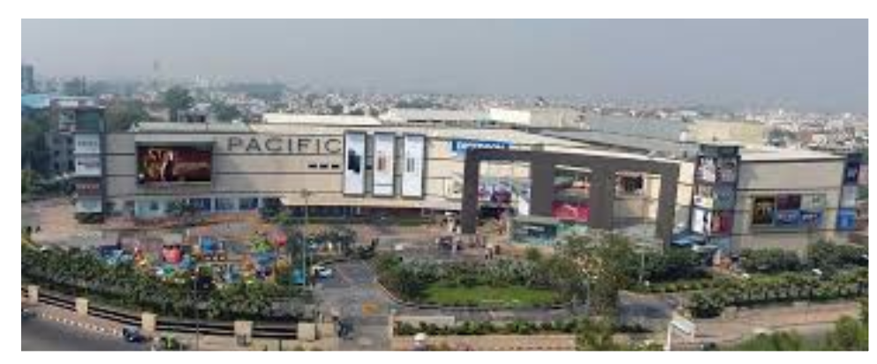

**Background**

Delhi, being the capital of India and also being the cultural hub is home to a number of businesses and Industries. NCR includes the cities which neighbour Delhi and have a lot of investment in various malls and industries. Some of the cities of NCR include Noida, Gurugram, Ghaziabad etc.

As there are endless opportunities, each and every street is filled with some shopping complex, Bars, restaurants etc.

**Business Statement**

Due to endless opportunities, a Businessman has to think about various factors including the type of business, area where the business will flourish etc. As these are the important factors which generate customers. This problem can be solved using data analysis technique.

**Data Analysis**

To solve this problem, we will need the various neighbourhoods of Delhi NCR. I have used Wikipedia for this.

* Latitude and Longitude of the neighbourhood is required to plot the map.

The data is acquired using Foursquare API. The data analysis is done using the below factors:

* Type of Place
* Name
* Area
* City

Foursquare API will provide many categories of venue data. We are particularly interested in Shopping malls. The project will use various techniques including Web Scraping, Foursquare API, Data Cleaning, Map Clustering.